**Officer Technical Report - 6 Week Report on EATF Pop Up Cycle A286 Chichester**

Scheme Location: A286 Chichester ring road (2km)Starting at St Richard’s Hospital, Spitalfield Lane and Ending at Southgate.

Scheme Scope: Lane one of the dual carriageway sections reallocated to provide lightly segregated cycle lanes in each direction. The existing cycle lane on the Northgate Gyratory system to be widened and protected with light segregation. Cycle symbols to be applied to the carriageway where light segregation is not possible. Shared bus and cycle lanes to be provided on Avenue de Chartres. A 20mph speed limit will apply to the extent of the scheme.

Build Start Date: 27th July 2020

Completion Date: 20th August 2020

Opening Date: 24th August 2020

Indicative Cost: Exact cost still to be confirmed

**Introduction**

In May the government announced £2 billion of new funding for walking and cycling over the next 5 years, with £225 million specifically allocated to the Emergency Active Travel Fund (EATF).

In addition, changes were made to the Traffic Management Act (2004) aimed at supporting the response to Covid-19 and building a green recovery. July saw the publication of ‘Gear Change: a bold vision for walking and cycling’, which describes the government’s vision to make England a great walking and cycling nation. The plan sets out the actions required at all levels of government to make this a reality, grouped under four themes: better streets for cycling and people, cycling and walking at the heart of decision-making, empowering and encouraging local authorities, enabling people to cycle and protecting them when they do.

* The EATF Chichester Pop-Up Cycle Lane scheme was introduced along the A286 Chichester ring road (2km)**.** The route starts at St Richard’s Hospital, Spitalfield Lane and ends at Southgate
* The temporary cycle route was completed on the 20th August 2020 and officially opened on the **24th August 2020**. The report shows cycle and vehicle data from the 10th of August until the 27th September

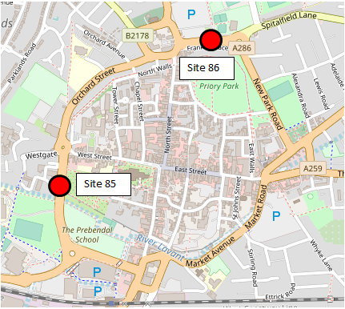

**1.1 - Stakeholder Consultation Process**

Due to the limited time available as set out in the grant conditions, it was not possible to undertake wider public consultation. The Traffic Management Act 2004 has been specifically amended to enable swift implementation of these emergency works. Consequently, consultation was limited to key stakeholders including, West Sussex and District/Borough Council Members; emergency services; bus operators; Freight Services and key WSCC Officers. It was expected that District and Borough Officers would undertake the necessary internal consultation with their own Members.

WSCC Members were consulted as follows:

|  |  |  |
| --- | --- | --- |
| **Location** | **Consultation** | **Keeping You Informed** |
| Chichester | 16/07/2020 | 23/07/2020 |

**1.2 - Feedback from District Council**

TBC

**1.3 - F&RS, SECAMB and Police Consultation**

We remain in regular contact with all three emergency services and are closely monitoring the impact on blue light services. Sussex Police have reported one incident where they were unable to pursue a blue light call due to Pop Up Scheme congestion in Chichester, when a suspect continued by foot from a moving vehicle.

Emergency Services have been invited to sit on the weekly ‘Safe Space’ working group. Some concerns have been raised that response times may be hindered due to the implementation of the pop-up cycle schemes and we are continuing to closely work alongside the emergency services to monitor this. West Sussex County Council have confirmed that emergency services responding under blue light emergency may use the temp cycle lanes if they cannot navigate through traffic but should be aware that they are likely to encounter cyclists and should exercise appropriate care.

A safe space working group meeting was held on 01/10/2020, representatives from ambulance service confirmed there have been no specific concerns over the Chichester scheme in previous 7 days.

**2.1 - Casualty Data**

Casualty data was reviewed before design and implementation of the route to compare with data for the duration of the route whilst live. Data for the first 6 weeks of route is not currently available but will be presented in future reports under this section. It is understood that there have been no known accidents.

**2.2 - Safety auditing & Inspections**

Road Safety Reviews were undertaken at the end of September by a qualified Road Safety Audit team. The Audit report is expected to be delivered on the 1st of October, not allowing sufficient time for review and inclusion within this report. The review also involved a representative from Sussex Police and the WSCC Cycling Development Officer.

West Sussex County Council has been assured that there is no major safety issues expected to be reported at this time. The safety review has acted upon all safety concerns and adjustments of schemes have been actioned for items such as signage and roundabouts.

**3.1 - Air Quality**

**Air Quality Monitoring Review**

The data in the chart below has been taken from Chichester District Council’s real-time air quality monitoring station in Orchard Street (near the junction with Northgate). It shows that the hourly average concentrations of nitrogen dioxide remain well below the UK limit/standard of 200 µgm-3 and remains in line with previous years air quality at this location.

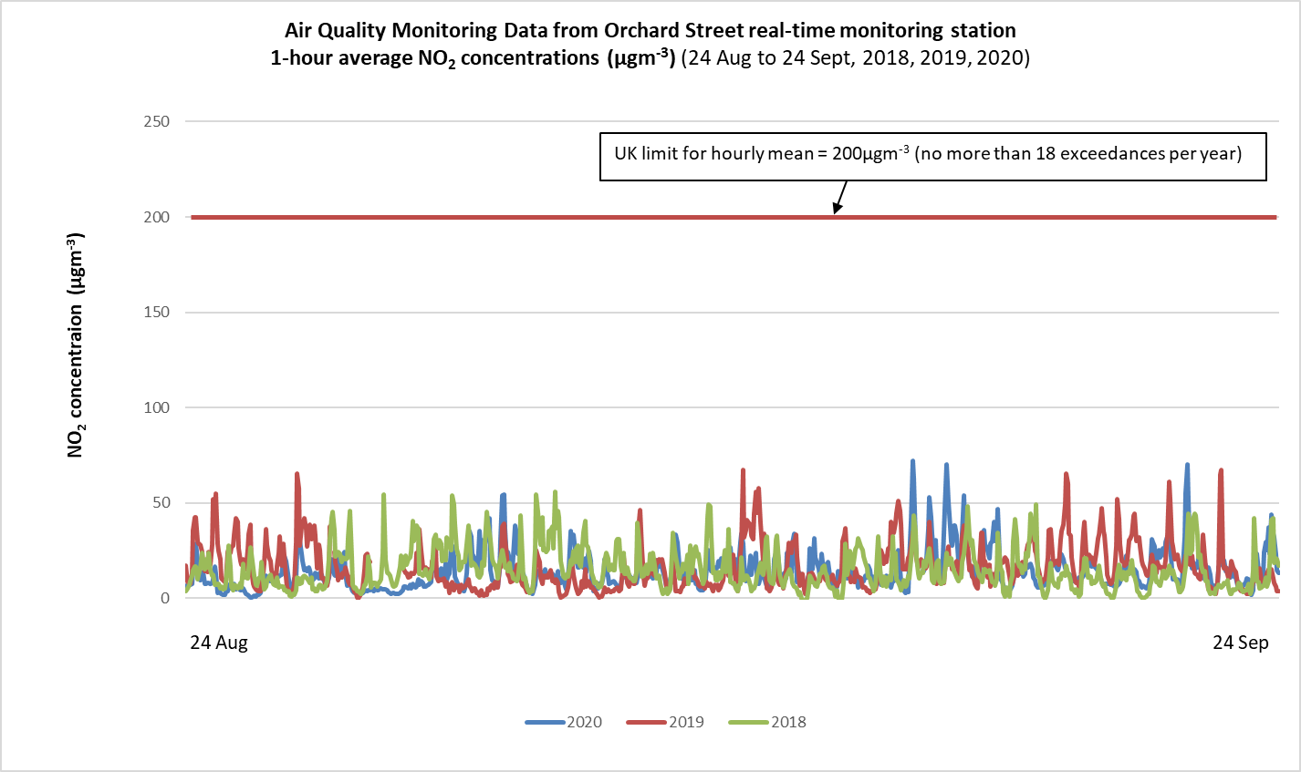

**3.2 – Drive Through Times & Speed Data**

**Drive Through Data**

WSCC Officers conducted a number of recorded and timed drive throughs of the Chichester scheme, in response to public concerns about traffic congestion and travel times:

* The routes were driven at 20mph at peak times (8-9am & 5-6pm) on multiple days.
* Average Route times were under 5 minutes in either direction. (Timed over 18 runs)
* The longest recorded journey was 8 minutes 15 seconds.
* Total Cyclists within the scheme boundaries over the 18 runs was 195, of these:74 used Pop Up Lane, 62 Cyclists with scheme boundary but on pavement and 59 were outside the cycle lane but within the scheme boundaries.

Average journey times and speeds through the scheme during busy times still appear to be within a range that might be expected. The table below shows actual average vehicle speed and journey times taken from a series of recent timed runs.

|  |  |  |  |  |
| --- | --- | --- | --- | --- |
| Fastest | Distance (miles) | Time (mins) | Time (seconds) | Speed (mph) |
| 08:00 - 09:00 Northbound | 1.3 | 3 | 44 | 20.9 |
| 08:00 - 09:00 Southbound | 1.1 | 3 | 25 | 19.3 |
| 17:00 - 18:00 Northbound | 1.3 | 3 | 35 | 21.8 |
| 17:00 - 18:00 Southbound | 1.1 | 3 | 31 | 18.8 |
|  |  |  |  |  |
| Average | Distance (miles) | Time (mins) | Time (seconds) | Speed (mph) |
| 08:00 - 09:00 Northbound | 1.3 | 4 | 33 | 17.1 |
| 08:00 - 09:00 Southbound | 1.1 | 4 | 50 | 13.7 |
| 17:00 - 18:00 Northbound | 1.3 | 4 | 55 | 15.9 |
| 17:00 - 18:00 Southbound | 1.1 | 4 | 40 | 14.1 |
|  |  |  |  |  |
| Slowest | Distance (miles) | Time (mins) | Time (seconds) | Speed (mph) |
| 08:00 - 09:00 Northbound | 1.3 | 5 | 45 | 13.6 |
| 08:00 - 09:00 Southbound | 1.1 | 8 | 15 | 8.0 |
| 17:00 - 18:00 Northbound | 1.3 | 7 | 28 | 10.4 |
| 17:00 - 18:00 Southbound | 1.1 | 5 | 46 | 11.4 |
|  |  |  |  |  |

**Speed Data**

The speed limit throughout the area affected by the cycle lane has been reduced from 30 mph to a temporary speed limit of 20 mph. The data captured from the Avenue de Chartres vehicle lanes has showed that the mean speed (across a 24 hour period) throughout the Northbound and Southbound lanes has remained similar, changing from an average of 32 mph to 31 mph after the scheme was introduced. Similarly, for Site 86, Oaklands Way, the mean vehicle speed has remained constant, 28 mph Eastbound and 24 mph Westbound.

**Site 85: Avenue de Chartres: Shared Bus/Cycle Lane and Traffic in each direction**





**Site 86: Oaklands Way: Cycle Lane and Traffic Lane in each direction**





**4.1 - Maintenance**

Contractors have responded to reports of issues and damage to the ‘pop up’ infrastructure. The maintenance costs associated with these repairs are funded by the EATF DfT funding bid. The maintenance costs associated with this scheme are contained within the appendix.

**5.1 - Feedback and Public Comment Database:**

All direct scheme relevant communications received are being noted, with a standardised response being sent to customers where appropriate. The Breakdown is as follows:

* Total number of Comment on Chichester via Email – 150

Categories of comments are displayed in the chart below.

**Categories of comments received:**

Primarily, congestion was the biggest concern, with lack of cyclists seen being a secondary concern for residents.

**Overall comments review**:

Most comments were against the scheme due to perceived cost of scheme in favour of cyclists. The perceived perception of the cycle routes is that they narrow carriageways and cause congestion. Based on the drive through date that was done the evidence suggests that this is not the case.

**Online Survey Data:**

Since the online survey has been live we have received a total of **2684** completed surveys.

Primarily responding as follows:

The survey asked the respondent if they had used or intended to use the new EATF A286 Chichester ring road (2km) temporary (“pop-up”) cycle lane with **344** having used it, **87** having intentions of using it, **1909** having no plans to use it and **344** not yet used it.

The survey also asked “**Would support or oppose the A286 Chichester temporary cycle lane being made permanent?”**

|  |  |
| --- | --- |
| **Option** | **Percent** |
| Strongly oppose | 80.70% |
| Oppose | 8.38% |
| Neither support nor oppose | 2.53% |
| Support | 1.97% |
| Strongly support | 6.41% |

The survey data will be reviewed in the next report against the survey data in this report.

**Other Considerations**

Grayling Well Park development is due to deliver cycle infrastructure improvements on Oakland’s way, these improvements include a toucan crossing, therefore to avoid additional disruption of any potential removal or amendments should be considered before being actioned.

**Appendix**

**Traffic Flow Counts**

**Site 85: Avenue de Chartres: Shared Bus/Cycle Lane and Traffic in each direction**

Traffic flow counts have been used to determine the number of vehicles using the vehicle lane alongside the pop-up cycle lane. Site 85, along Avenue de Chartres (Northbound and Southbound combined) typically sees an average of 11,200 vehicles using this road every day. The graph below details the change in vehicles using this road, with no evidence of vehicle numbers changing from the introduction of the scheme, but an increase in vehicles from September as school journeys resumed.

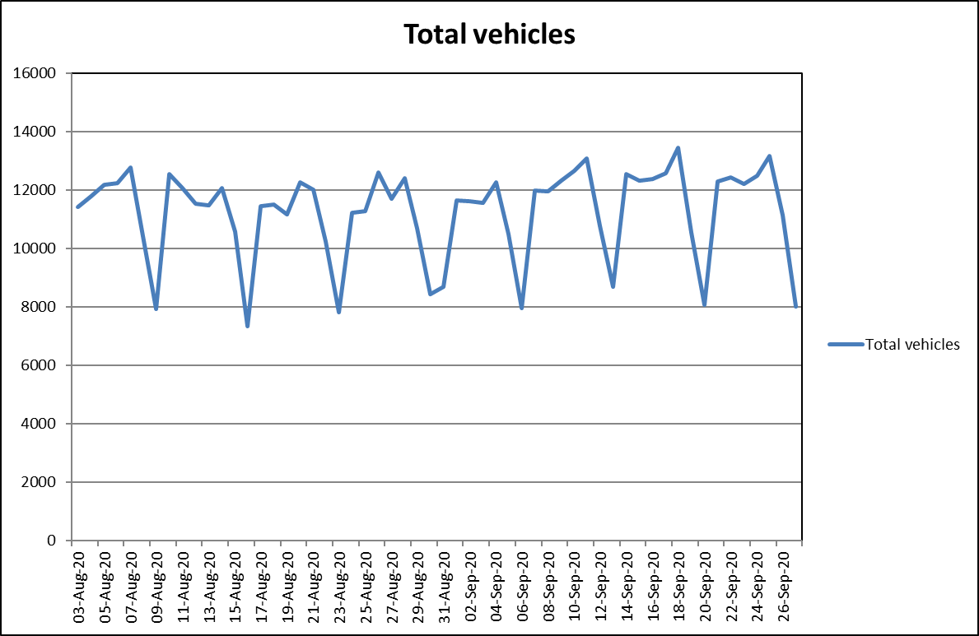

**Site 86: Oaklands Way: Cycle Lane and Traffic Lane in each direction**

Site 86, along Oaklands Way (Eastbound and Westbound combined) typically sees 19,100 vehicles using the road each day. Similarly, to Avenue de Chartres, there appears to be a slight increase in vehicle numbers from the week commencing 7th September, which is likely to coincide with schools reopening across the city. The cycle lanes do not appear to be affecting the number of vehicles using the road.

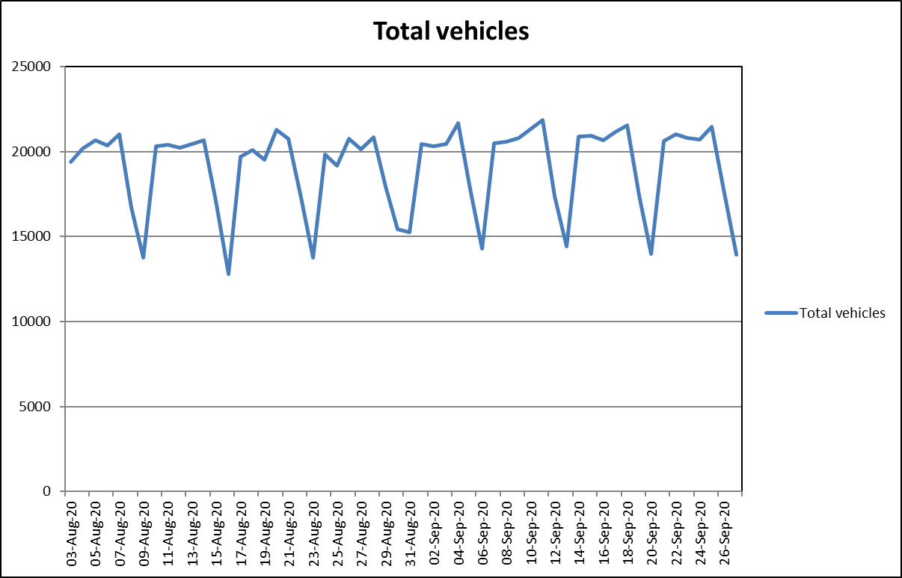

**Cycle Counts**

As with vehicle counting, it was paramount to capture the number of cyclists using the pop-up cycle lanes across the sites in Chichester. As mentioned previously, there are concerns around the counter loops used in the cycle lanes as it is possible for cyclists to use the lane but not cycle over the counting loops. This is an issue that is currently being discussed and resolved with the counter loop installers. It is likely that the true cyclist figures will increase with new fitment of loops covering the entire cycle lane.

**Site 85: Avenue de Chartres: Shared Bus/Cycle Lane and Traffic in each direction**

The table below shows the percentage change in number of cyclists using the Avenue de Chartres cycle lane. The numbers of cyclists per week utilising this part of the scheme increased from approximately 220 per week to up to 426 per week, during the week commencing 7th September.





**Site 86: Oaklands Way: Cycle Lane and Traffic Lane in each direction**

The table below shows the percentage change in number of cyclists using the Oaklands Way cycle lane. The numbers of cyclists per week utilising this part of the scheme increased from approximately 250 cyclists per week to up an average of 406 per week, over the last four weeks, from 31st August to the 27th September.





**Vehicle Speeds: Site 86: Oaklands Way: Cycle Lane and Traffic Lane in each direction**

**West Weekly**

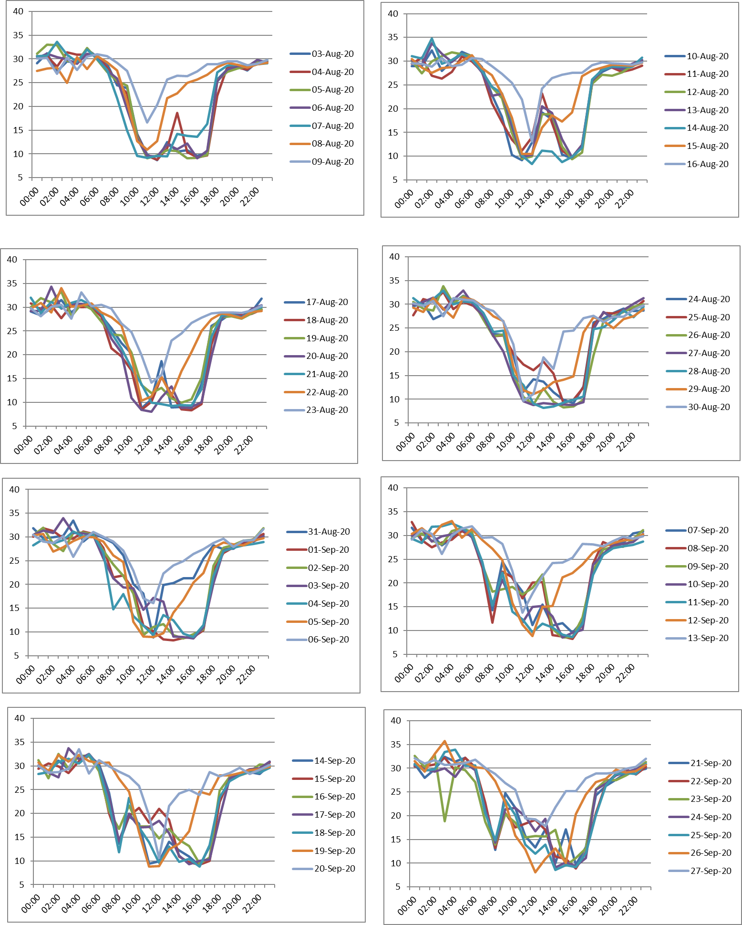

**Vehicle Speeds: Site 86: Oaklands Way: Cycle Lane and Traffic Lane in each direction**

**East Weekly**

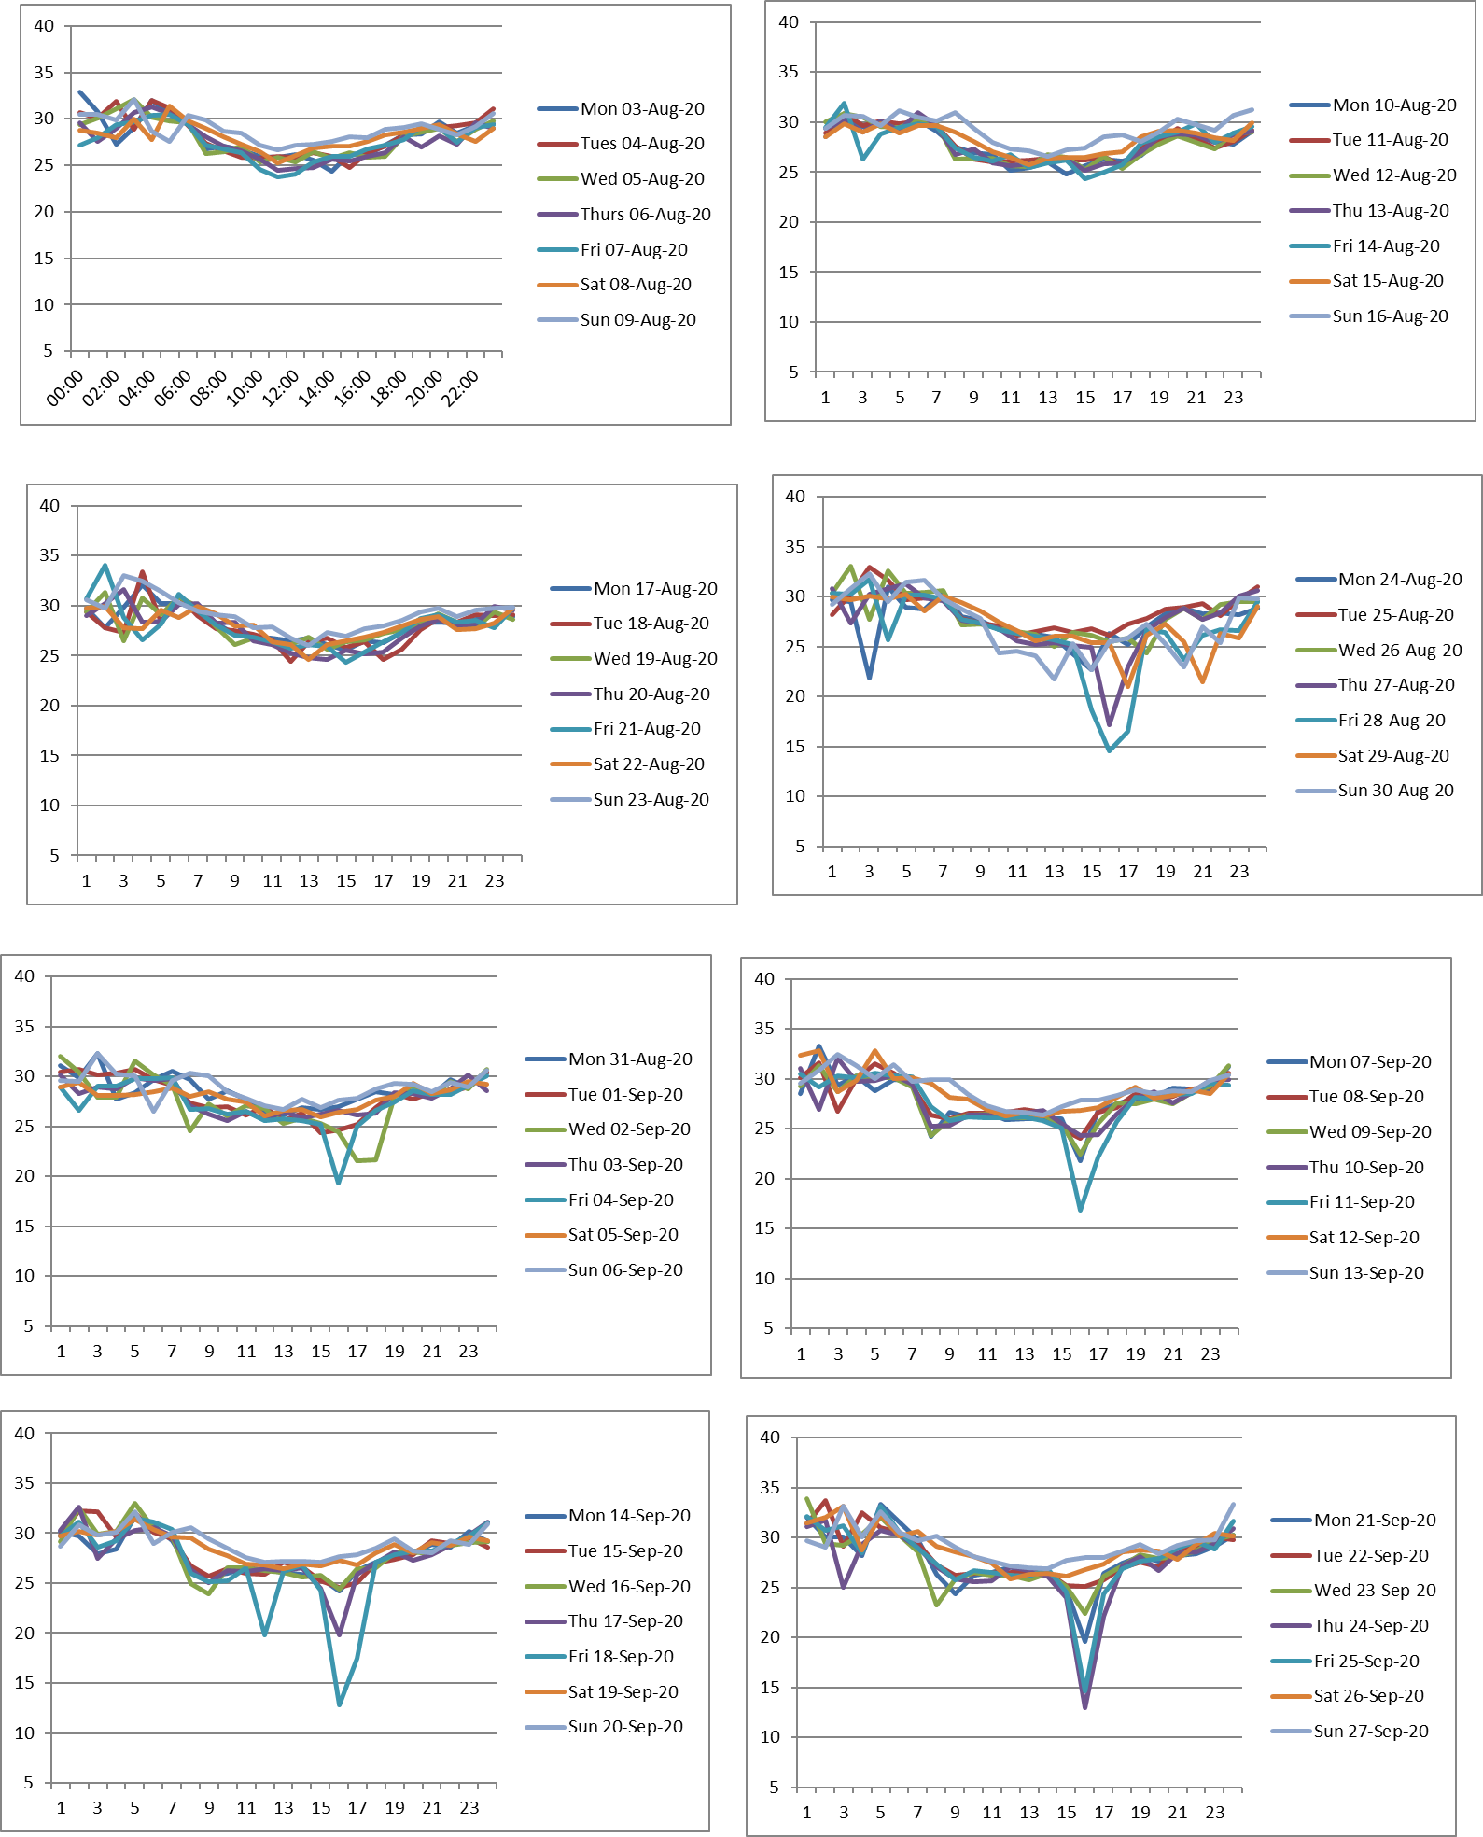

**Vehicle Speeds: Site 85: Avenue de Chartres: Shared Bus/Cycle Lane and Traffic in each direction**

**Eastbound**

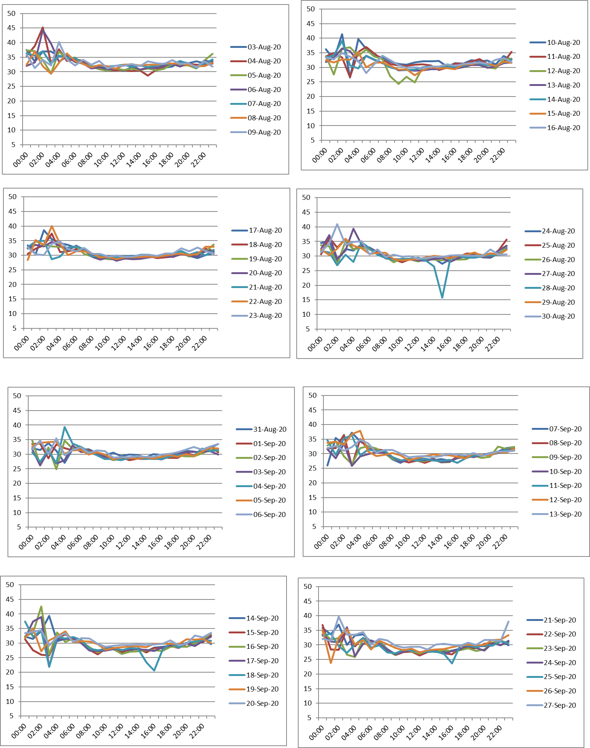

**Vehicle Speeds: Site 85: Avenue de Chartres: Shared Bus/Cycle Lane and Traffic in each direction**

**Westbound**

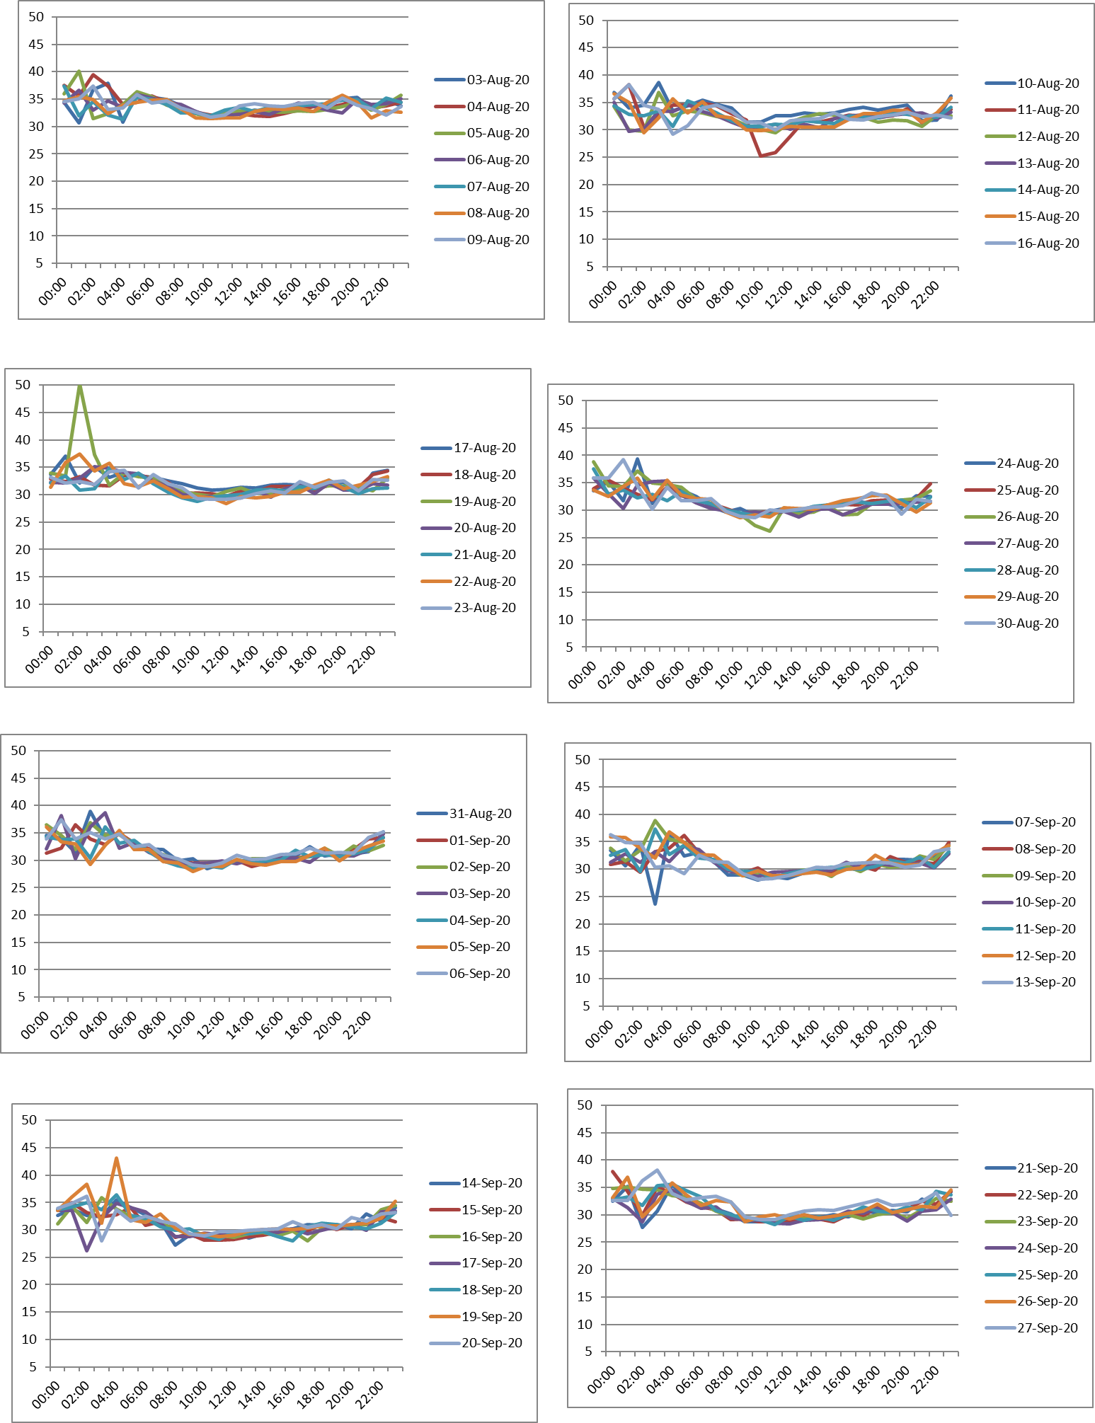

**Maintenance Costs**

|  |  |  |
| --- | --- | --- |
| Chichester Pop up Cycle Scheme EATF - Repairs & Maintenance | | |
| Unit Rate / Day Rate | No. of Wands Repaired | Total Cost |
| **Unit Rate - £35 Day Rate - £735** | **12** | **£1,155** |
|

**Vehicle Speed and Volume Comparison Data**

